



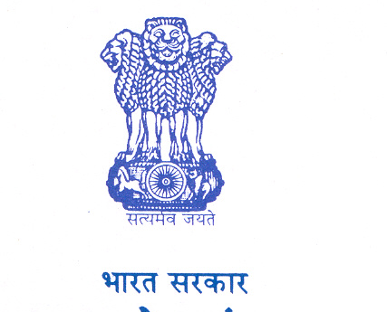

**Government of India**

**Development Commissioner (MSME)**

**Ministry of Micro, Small & Medium Enterprises**

***Application for Two Week***

***Entrepreneurship Development Programme***

Organized By

**MSME-Development Institute, Cuttack**

**Objective:** To sensitize prospective entrepreneurs to set up their ventures for self employment.

**Who should apply**: Man/Woman having age 18 years above.

**Duration: 1.9.2021 to 16.9.2021**

**Venue:**National Youth for Social Justice Trust, Plot No-508/565, Lane 5, Mallick Cpmplex,Jagamara Traffic Square, Bhubaneswar

**Participation Fee: Nil**

**Eligibility: Having educational qualification 8th pass or above**

**Registration: The details of the participants may be submitted to MSME-DI, College Square, Cuttack**

**email:** [**dcdi-cuttack@dcmsme.gov.in**](mailto:dcdi-cuttack@dcmsme.gov.in)

**Intake capacity**- **30** ( On first-cum-first-serve basis)

**Last date for submission of application:31.08.2021**

**Please Contact:**

The Director, MSME Development Institute, College Square, Cuttack, Odisha-03,

Tel: 0671-2548049, Fax: 2950011

Sri B.P. Behera, Asst. Director, Mob:9438203044, [www.msmedicuttack.gov.in](http://www.msmedicuttack.gov.in),

Email: dcdi-cuttack@dcmsme.gov.in







**Government of India**

**Development Commissioner (MSME)**

**Ministry of Micro, Small & Medium Enterprises**

***Application for Two Week***

***Entrepreneurship Development Programmes***

Organized By

**MSME-Development Institute, Cuttack**

**Objective:** To sensitize prospective entrepreneurs to set up their ventures for self employment.

**Who should apply**: Man/Woman having age 18 years above.

**Duration: 01.09.2021 to 16.9.2021 & 02.09.2021 to 17.09.2021**

**Venue:**Rotary Community Centre, Barmunda Housing Board, (Municipality U.P. School Campus, Fire Station Square, Bhubaneswarand Badasamantrapur, near- SBI, Bhubaneswar

**Participation Fee: Nil**

**Eligibility: Having educational qualification 8th pass or above**

**Registration: The details of the participants may be submitted to MSME-DI, College Square, Cuttack**

**email:** [**dcdi-cuttack@dcmsme.gov.in**](mailto:dcdi-cuttack@dcmsme.gov.in)

**Intake capacity**- **30** in each( On first-cum-first-serve basis)

**Last date for submission of application:31.08.2021**

**Please Contact:**

The Director, MSME Development Institute, College Square, Cuttack, Odisha-03,

Tel: 0671-2548049, Fax: 2950011

Sri S.K Sahu, Asst. Director, Mob:9437267097, [www.msmedicuttack.gov.in](http://www.msmedicuttack.gov.in),

Email: dcdi-cuttack@dcmsme.gov.in